26

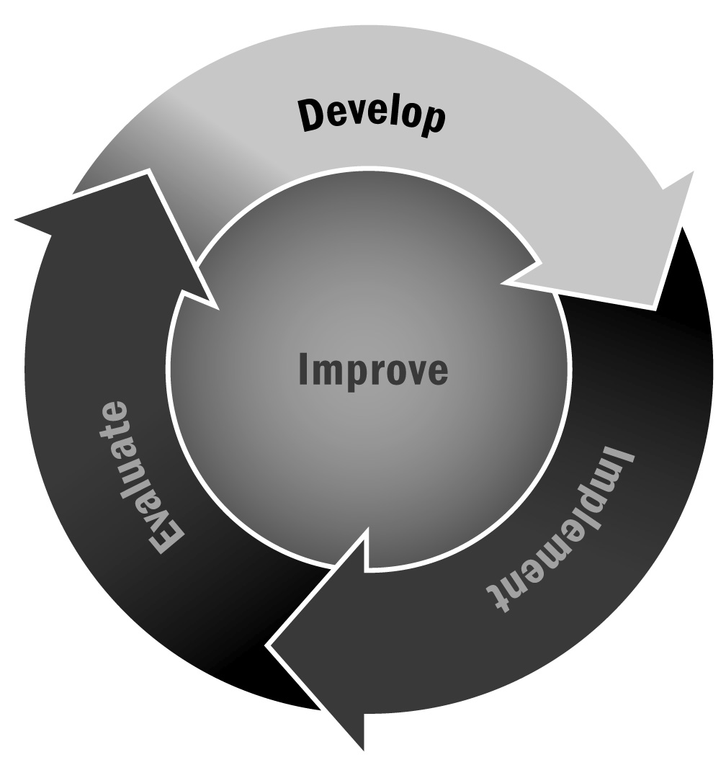
Self-Assessment of Effective Qualities
In Chapter 1, you learned about the importance of reflective practice for program staff. Providing staff members an opportunity to identify their strengths and opportunities for improvement—rather than telling them how to improve—is an effective way to promote professional development and improve program quality. Establishing an open and reflective culture will encourage staff growth and retention.
Directions: Before completing this tool, revisit the previous tool on developing as an afterschool and expanded learning professional (Tool 25). Review how you rated yourself. Now, in the center column, read the list of qualities relating to staff effectiveness. Think about your strengths for each quality and list them in the column on the left. Now reflect on the areas of growth for each quality and list them in the column on the right.

My Strengths | Qualities of Effectiveness | My Areas for Growth
Engages and supports all youth
- Always treats all young people equally
- Knows the typical benchmarks for growth and development
- Uses knowledge to provide a program that identifies, celebrates, and builds on youth strengths
- Employs youth development principles
- Ensures the safety and well-being of all youth
- Creates a warm and welcoming program environment
- Knows the names of all youth and what is going on in their lives
- Builds respectful, reciprocal relationships among youth and staff
- Provides opportunities for choice in activities
- Provides opportunity for youth voice and authentic decision-making
- Allows opportunities for reflection
Plans program schedule/activities intentionally
- Uses provided program planning tools to plan program schedule/activities in advance
- Plans activities by using data (see below)
- Plans activities in consideration of the principles of SAFE (sequenced, active, focused, and explicit) to ensure skill-building opportunities
- Reflects on program schedule/activities to make improvements
Uses data to drive program
- Conducts self-assessments or observes activities and uses program observation data to make improvements
- Asks youth, teachers, and families what youth are working on in other settings and where they may need additional support
- Conducts formal and informal check-ins with youth and their families on program satisfaction; uses data to make improvements
Develops relationships with the community, school, and families
- Interacts frequently with teachers, school personnel, families, and community members
- Shares data
- Collaboratively develops strategies
- Celebrates success publicly
Develops as a professional afterschool and expanded learning program staff member
- Committed to professional growth by engaging in professional development activities (conferences, classes, technical assistance, or coaching) related to afterschool and expanded learning, youth development, education, and in specific content areas (e.g., STEM)

